P10_Creative1_Animal

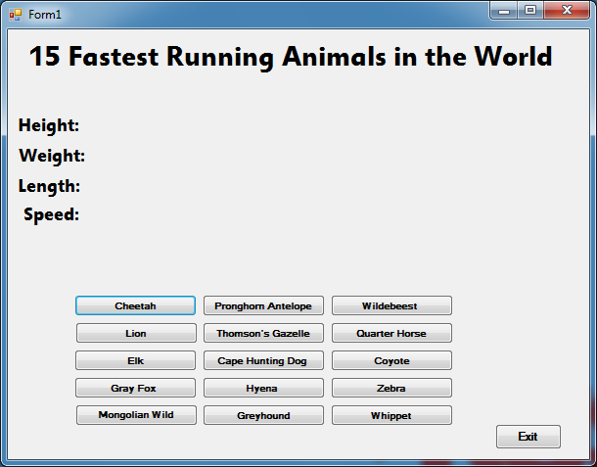

Private Sub btnZebra_Click(sender As System.Object, e As System.EventArgs) Handles btnZebra.Click

lblDisplay1.Text = "Average 3.6ft"

lblDisplay2.Text = "Average about 500-700 lbs"

lblDisplay3.Text = "65-80 cm"

lblDisplay4.Text = "40mph"

End Sub

Private Sub btnExit_Click(sender As System.Object, e As System.EventArgs) Handles btnExit.Click

Application.Exit()

End Sub

Private Sub btnCheetah_Click(sender As System.Object, e As System.EventArgs) Handles btnCheetah.Click

lblDisplay1.Text = "30+ inches at shoulder"

lblDisplay2.Text = "69-140 lbs."

lblDisplay3.Text = "4 feet"

lblDisplay4.Text = "70mph"

End Sub

Private Sub btnPronghorn_Click(sender As System.Object, e As System.EventArgs) Handles btnPronghorn.Click

lblDisplay1.Text = "Approx 3 inches at shoulder"

lblDisplay2.Text = "Male 90–140 lbs, Female 75–105 lbs"

lblDisplay3.Text = "4.1–4.8 ft"

lblDisplay4.Text = "61mph"

End Sub

Private Sub btnWildebeest_Click(sender As System.Object, e As System.EventArgs) Handles btnWildebeest.Click

lblDisplay1.Text = "50 to 58 inches at shoulder"

lblDisplay2.Text = "265 to 600 lbs"

lblDisplay3.Text = "4.1–4.8 ft"

lblDisplay4.Text = "50mph"

End Sub

Private Sub btnLion_Click(sender As System.Object, e As System.EventArgs) Handles btnLion.Click

lblDisplay1.Text = "Average lion is roughly 4 feet at the shoulder."

lblDisplay2.Text = "Male lions between 390 and 430 lbs on average,Females generally between 270 and 315 lbs."

lblDisplay3.Text = "1-3 meter, not including the tail"

lblDisplay4.Text = "50mph"

End Sub

Private Sub btnGazelle_Click(sender As System.Object, e As System.EventArgs) Handles btnGazelle.Click

lblDisplay1.Text = "20 to 26 inches"

lblDisplay2.Text = "20kg"

lblDisplay3.Text = "80cm"

lblDisplay4.Text = "50mph"

End Sub

Private Sub btnQuarterHorse_Click(sender As System.Object, e As System.EventArgs) Handles btnQuarterHorse.Click

lblDisplay1.Text = "14.3 to 16hh"

lblDisplay2.Text = "1000-1300 lbs"

lblDisplay3.Text = "16hh+"

lblDisplay4.Text = "47.5mph"

End Sub

Private Sub btnElk_Click(sender As System.Object, e As System.EventArgs) Handles btnElk.Click

lblDisplay1.Text = "To shoulder 5-6 ft"

lblDisplay2.Text = "Males (Bull) 700 to 1000 lbs.Females (Cow) 500-600 lbs"

lblDisplay3.Text = "Average of 8 feet"

lblDisplay4.Text = "45mph"

End Sub

Private Sub btnCapeHuntingDog_Click(sender As System.Object, e As System.EventArgs) Handles btnCapeHuntingDog.Click

lblDisplay1.Text = "Average shoulder height between 24 and 30 inches"

lblDisplay2.Text = "Average weight ranges from 37 to 60 lbs"

lblDisplay3.Text = "Average body length, not including the tail, between 2 1/2 and 3 1/2 feet"

lblDisplay4.Text = "45mph"

End Sub

Private Sub btnCoyote_Click(sender As System.Object, e As System.EventArgs) Handles btnCoyote.Click

lblDisplay1.Text = "Shoulder height varies between 11/2 to 2 feet"

lblDisplay2.Text = "Typical weight is between 15 and 45 lbs"

lblDisplay3.Text = "Total length of a coyote can exceed 60 inches"

lblDisplay4.Text = "43mph"

End Sub

Private Sub btnGrayFox_Click(sender As System.Object, e As System.EventArgs) Handles btnGrayFox.Click

lblDisplay1.Text = "Average 32 to 45 inches"

lblDisplay2.Text = "Ranges from 7 to 14 lbs, 10 to 11 lbs is average"

lblDisplay3.Text = "32 to 45 inches"

lblDisplay4.Text = "42mph"

End Sub

Private Sub btnHyena_Click(sender As System.Object, e As System.EventArgs) Handles btnHyena.Click

lblDisplay1.Text = "Average 3.6ft"

lblDisplay2.Text = "Adult male spotted hyenas weigh 89-121 lbs., while females weigh 98-141 lbs."

lblDisplay3.Text = "65-80 cm"

lblDisplay4.Text = "40mph"

End Sub

Private Sub btnMongolianWildDonkey_Click(sender As System.Object, e As System.EventArgs) Handles btnMongolianWildDonkey.Click

lblDisplay1.Text = "Average 125-145 cm"

lblDisplay2.Text = "507.1 lbs"

lblDisplay3.Text = "Average 7'4 feet"

lblDisplay4.Text = "40mph"

End Sub

Private Sub btnGreyhound_Click(sender As System.Object, e As System.EventArgs) Handles btnGreyhound.Click

lblDisplay1.Text = "Average Males 28-30 inches, Females 27-28 inches"

lblDisplay2.Text = "Males 65-80 lbs, Females 60-70 lbs"

lblDisplay3.Text = "Average 3-5 feet"

lblDisplay4.Text = "39.5mph"

End Sub

Private Sub btnWhippet_Click(sender As System.Object, e As System.EventArgs) Handles btnWhippet.Click

lblDisplay1.Text = "Average Males 28-30 inches, Females 27-28 inches"

lblDisplay2.Text = "25-45 lbs."

lblDisplay3.Text = "Average 2-3 feet"

lblDisplay4.Text = "35.5mph"

End Sub

End Class